**AutoGraph**

**Latest Submission Grade 100%**

**1.**

Question 1

Which of the following statements is *false* about Graph approach?

**1 / 1 point**



Portability



Parallelism



Easier debugging



Faster compilation

**Correct**

Correct! This statement is false. Since operations don’t execute until the Graph is fully designed, it can be tricky to debug.

**2.**

Question 2

Which of the following statements is *true* for *tf.cond* ?

**1 / 1 point**



*tf.cond* is an alternative to using *if/else* statements in Graphs, as its execution is much faster than *if/else* statements.



Graph execution does not support *if/else* statements. To replicate that effect you use *tf.cond*

**Correct**

Correct!

**3.**

Question 3

Consider the following code:

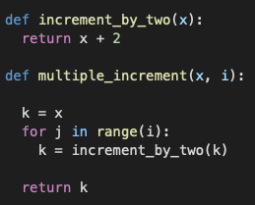

How do you convert *both* of these functions to execute in *Graph* mode? Check all that are true.

**1 / 1 point**



By adding the decorator, @tf.function, only above the function definition of *multiple_increment*

**Correct**

Correct! If a function is decorated with ‘@tf.function’, then the functions that it calls will also be included in graph mode.



By adding the decorator, @tf.function, above the definitions of both of the functions.

**Correct**

Correct!



By adding the decorator, @tf.autograph, above the definitions of both of the functions.



By adding the decorator, @tf.function, only above the function definition of *increment_by_two*

**4.**

Question 4

Function written in Eager mode when converted to Graph accommodates different data types all in one, so you don’t have to define similar functions for different data types.

**1 / 1 point**



True



False

**Correct**

Correct!

**5.**

Question 5

Which of the following is the correct syntax to display the auto-generated AutoGraph code if your function name is *my_function*?

**1 / 1 point**



tf.autograph.code(my_function)



tf.autograph.to_code(my_function.python_function)



tf.autograph.to_code(my_function)



tf.autograph.code(my_function.python_function)

**Correct**

Correct!

**6.**

Question 6

Consider the following code, what will be the output?

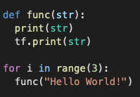

**1 / 1 point**



Hello World!

Hello World!

Hello World!



Hello World!

Hello World!

Hello World!

Hello World!



Hello World!

Hello World!

Hello World!

Hello World!

Hello World!

Hello World!

**Correct**

Correct! Even though tf.print is used, we still get 6 print statements because the function is not decorated to run as a Graph.